Sample Letter:
Dear Elsie:
Have you ever seen Noah’s Ark? Well, none of us has. God had Noah build the Ark thousands of years ago. But in Kentucky an organization called Answers in Genesis built a full-size replica of the Ark. It measures 510 feet long. In the book of Genesis in the Bible God told Noah just how long, high and wide to build it. It was also to have three decks in it. God even told Noah to make a door in the side of the Ark and a long slim window on the top for light and ventilation.
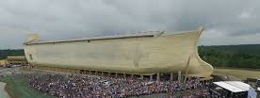
When you really study the subject of the Ark it is fascinating. The people of Noah’s day were extremely wicked. The Bible says in Genesis 6 that the thoughts of their hearts were only evil continually. They had sunk so low they did not even have one righteous thought. Only Noah and his family were seen by God to be righteous. It took 120 years to build. The whole time the people could have repented but they did not. Noah was commanded to put animals on the Ark and every kind of food.
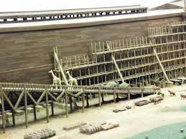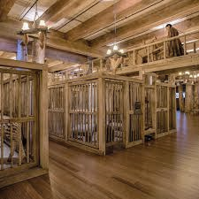
God brought the animals Cages had been built Food had been stored
The inside of the Ark was huge. Noah his family, and the animals lived on the Ark for 370 days. Outside of the Ark God brought rain for 40 days and 40 nights. Plus, He broke up the fountains of the great deep, i.e. oceans. Water was forced up over the continents with huge tidal waves that changed the dry land forever. It caused many layers of sedimentary rock, some of which are filled with sea shells and fish fossils that were brought up from the ocean bottom. I have seen sea shells imbedded in rock high in the Rocky Mountains. Near Kemmerer Wyoming is a fossil grave yard that is filled with fish and animals of various kinds all mixed together. It is an amazing study to learn what the Genesis flood did to the earth. But the main thing to remember is that it destroyed all mankind except for Noah, his wife, three sons and their wives.
Remember the door in the side of the Ark? Jesus taught us that He is the Door. John 10:9-10
“I am the door. If anyone enters by Me, he will be saved, and will go in and out and find pasture. The thief does not come except to steal, and to kill, and to destroy. I have come that they may have life, and that they may have it more abundantly.”
In Noah’s day people could be saved from God’s terrible judgement just by entering the door of the ark. After God closed the door, He waited another seven days before the rain started. No one else asked to get in. When the rain came it was too late. . . forever. Our opportunity to enter eternal life through Jesus Christ is now. The door is still open. But if we neglect to come to Christ for the forgiveness of our sins the opportunity will one day be shut . . . forever. Jesus died for you and rose to life the third day. If you have never come to the Lord personally to ask His forgiveness please do it now. Don’t wait!
Wade Wadsworth

Sample Letter:
Dear Henry:
Back in the 1950’s and 60’s there were so may changes taking place in our country and in the world. It seems we were all living on the edge of world war three. Remember that? There was the cold war, the space race, and the Cuban missile crisis. The Salk vaccine for polio came out in the 1953. I remember getting my first polio shot.
Another thing that really stands out in my mind was the Billy Graham Evangelistic Crusades on television. They would come on TV about every six months or so. It was incredible to see so many people gathered in one place.
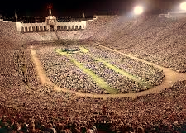
There seemed to be a spiritual hunger among people at that time. My sister gave me a Bible and I used to read it in bed before turning the light out for the night.
Billy Graham was raised on a dairy farm and milked cows before and after going to school. It is interesting how many times God calls men from the farms and ranches to preach the Gospel.
When asked if anything surprised him, Billy Graham said he was “surprised by how fast life went by.” We can all relate to that one, can’t we?
Reading the Bible caused me to understand that I was lost because of my sin. The Bible says in Romans 3:23 “for all have sinned and fall short of the glory of God.” I knew that is true of me. Even as a boy I could not obey all of the Boy Scout Law let alone all of God’s laws. I was a member of a church and went to church every Sunday. But I knew if my heart were to stop beating, I would go to hell and I did not know what to do about it.
Billy Graham’s ministry helped me to understand what to do about my sin problem. I needed God’s forgiveness. I needed a personal relationship between me and the Lord. The Bible says Romans 6:23 “For the wages of sin is death, but the gift of God is eternal life in Christ Jesus our Lord.” Romans 5:8 “But God demonstrates His own love toward us, in that while we were still sinners, Christ died for us.” John 10:10-11 Jesus said “the thief does not come except to steal, and to kill, and to destroy. I have come that they may have life, and that they may have it more abundantly. I am the good shepherd. The good shepherd gives His life for the sheep.” Isaiah 59:2 “But your iniquities have separated you from your God; And your sins have hidden His face from you…” 1 Timothy 2:5 For there is one God and one Mediator between God and men, the Man Christ Jesus, John 14:6 “Jesus said to him, ‘I am the way, the truth, and the life. No one comes to the Father except through Me.’” Ephesians 2:8-9 “For by grace you have been saved through faith, and that not of yourselves; it is the gift of God, not of works, lest anyone should boast.” Romans 10:9
“that if you confess with your mouth the Lord Jesus and believe in your heart that God has raised Him from the dead, you will be saved.”
When I understood these things, I prayed to the Lord asking Him to forgive my sins, to come into my heart and life. I knew I had been changed. I had so much to learn in my new life with Jesus as my very own Savior.
Please talk to the Lord Jesus personally. Confess your sins and ask His forgiveness. Make sure He is your very own Savior.
Wade Wadsworth

